Policies_Verifying Agency Billed Policy_Instance43_29-May-2018_03-51-09_AM_SingleSignOn.png

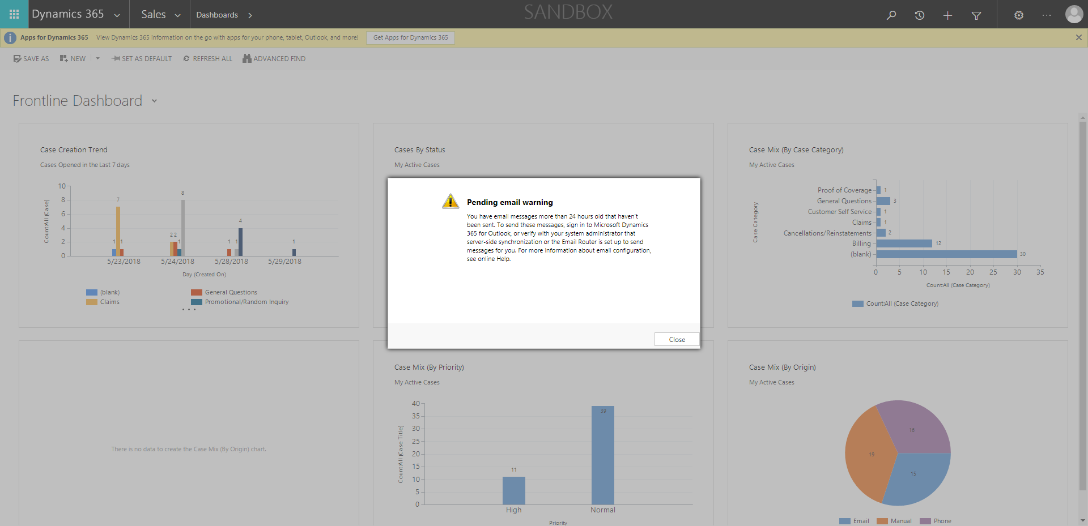

Policies_Verifying Agency Billed Policy_Instance43_29-May-2018_03-51-15_AM_SingleSignOn.png

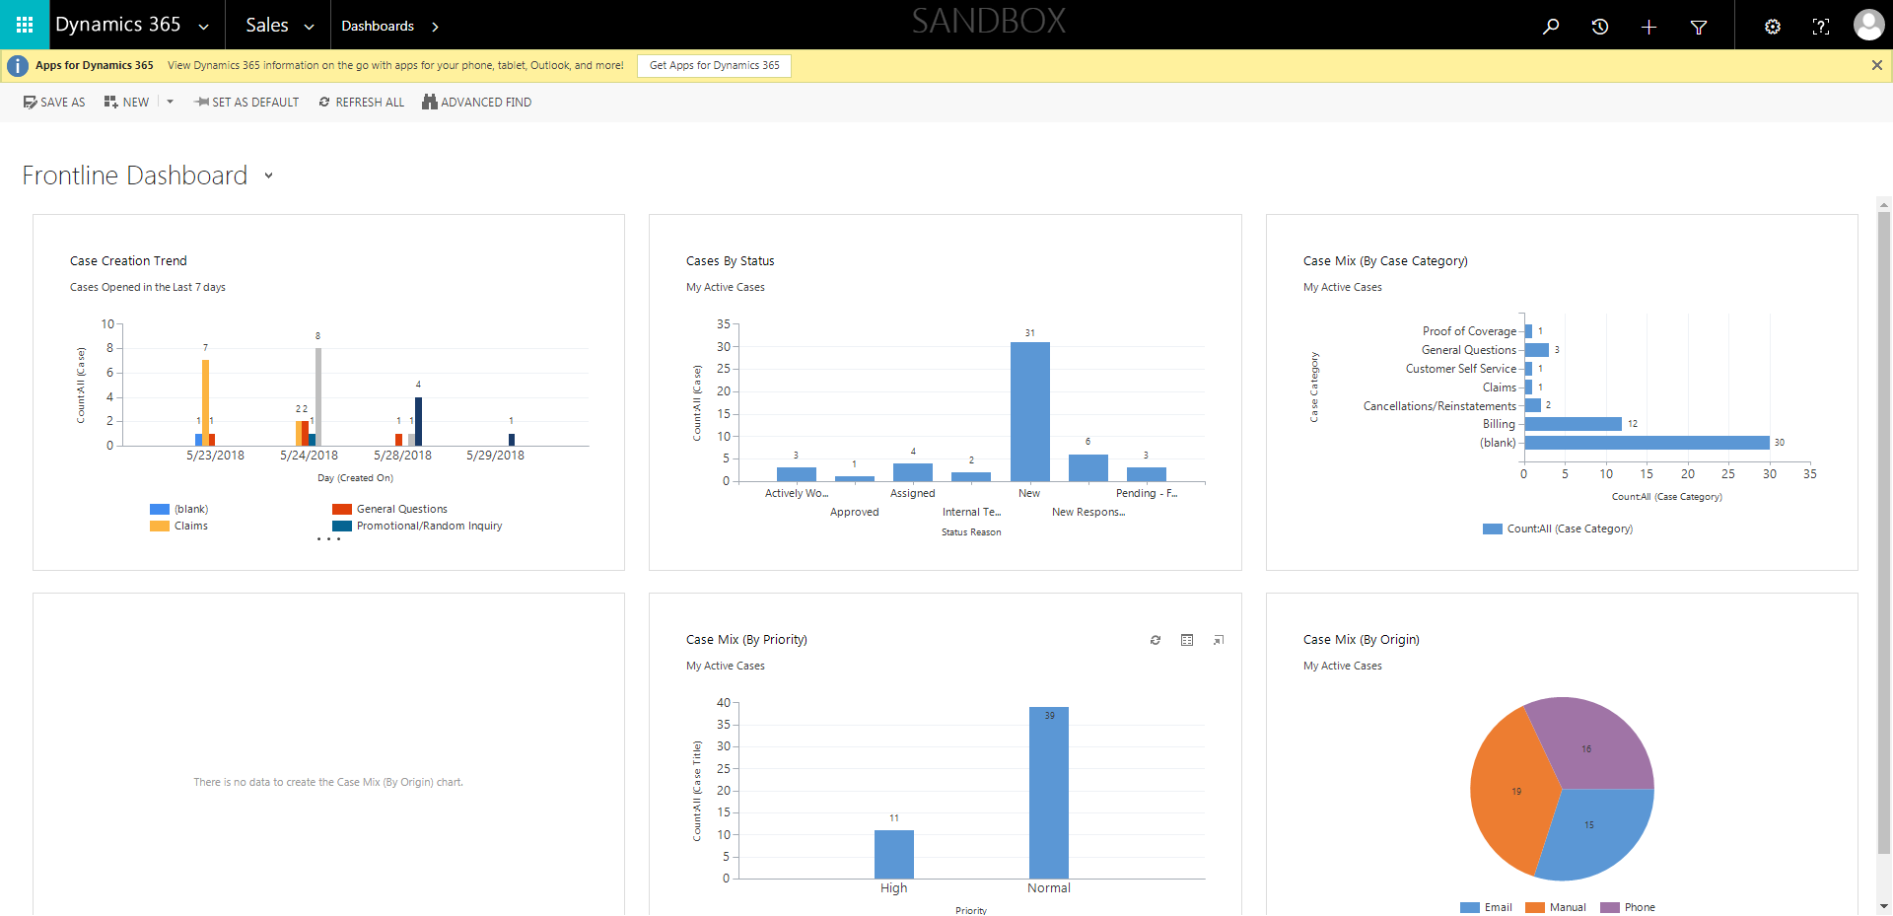

Policies_Verifying Agency Billed Policy_Instance43_29-May-2018_03-50-40_AM_MouseClickActiononStaleElement.png

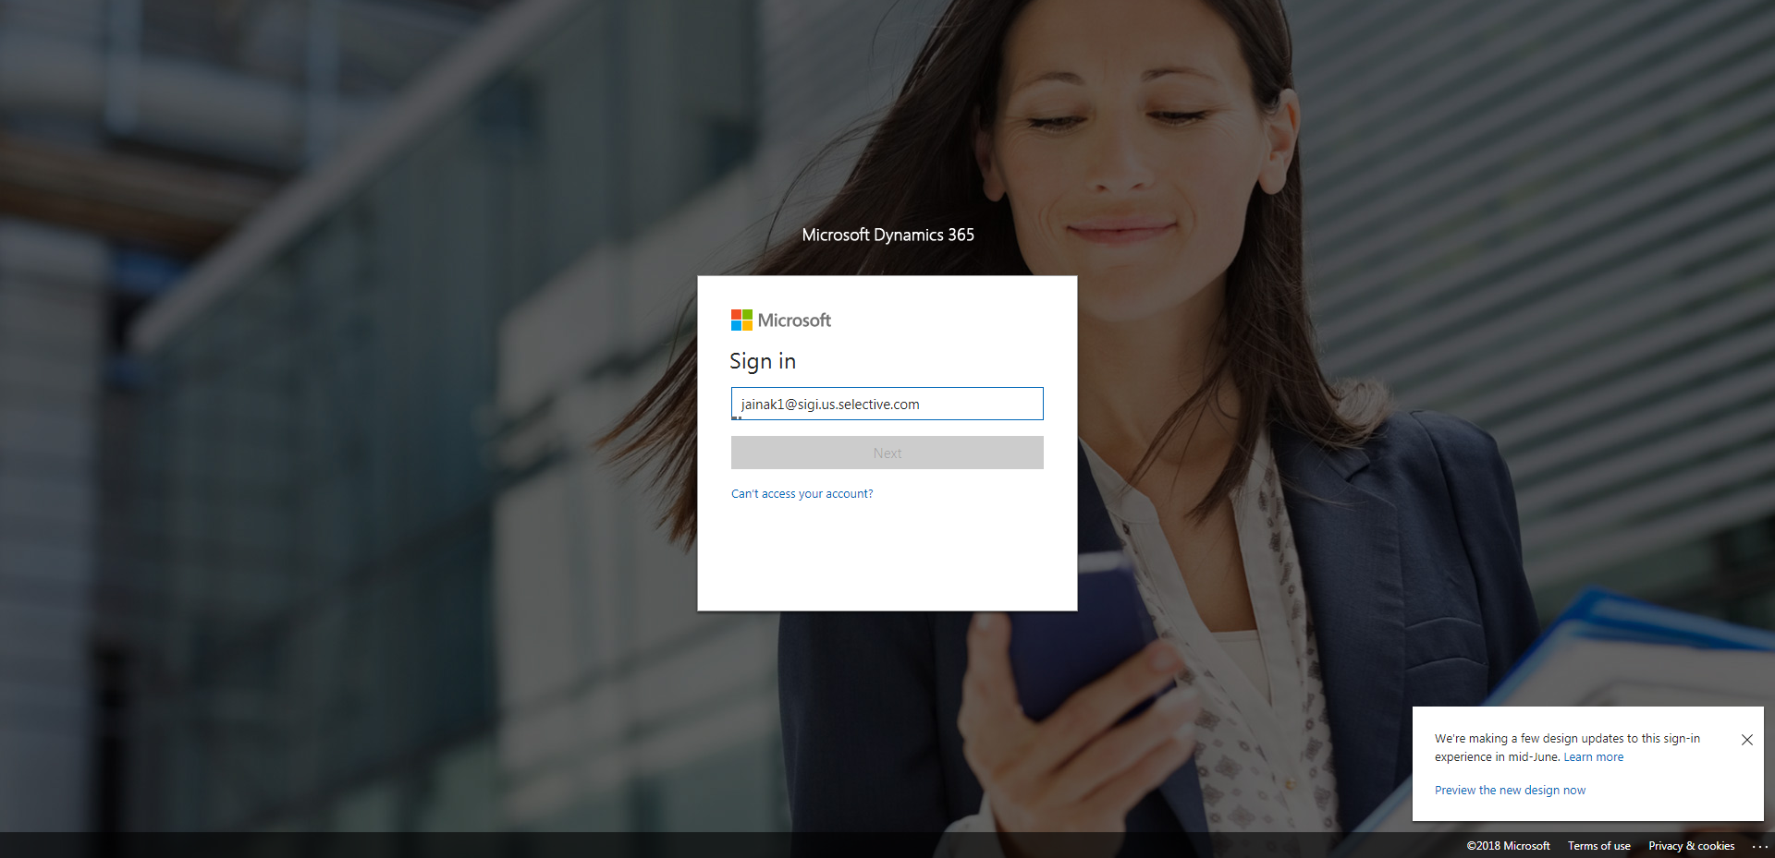

Policies_Verifying Agency Billed Policy_Instance43_29-May-2018_03-52-40_AM_ValidationofAgencyBilledPolicy.png

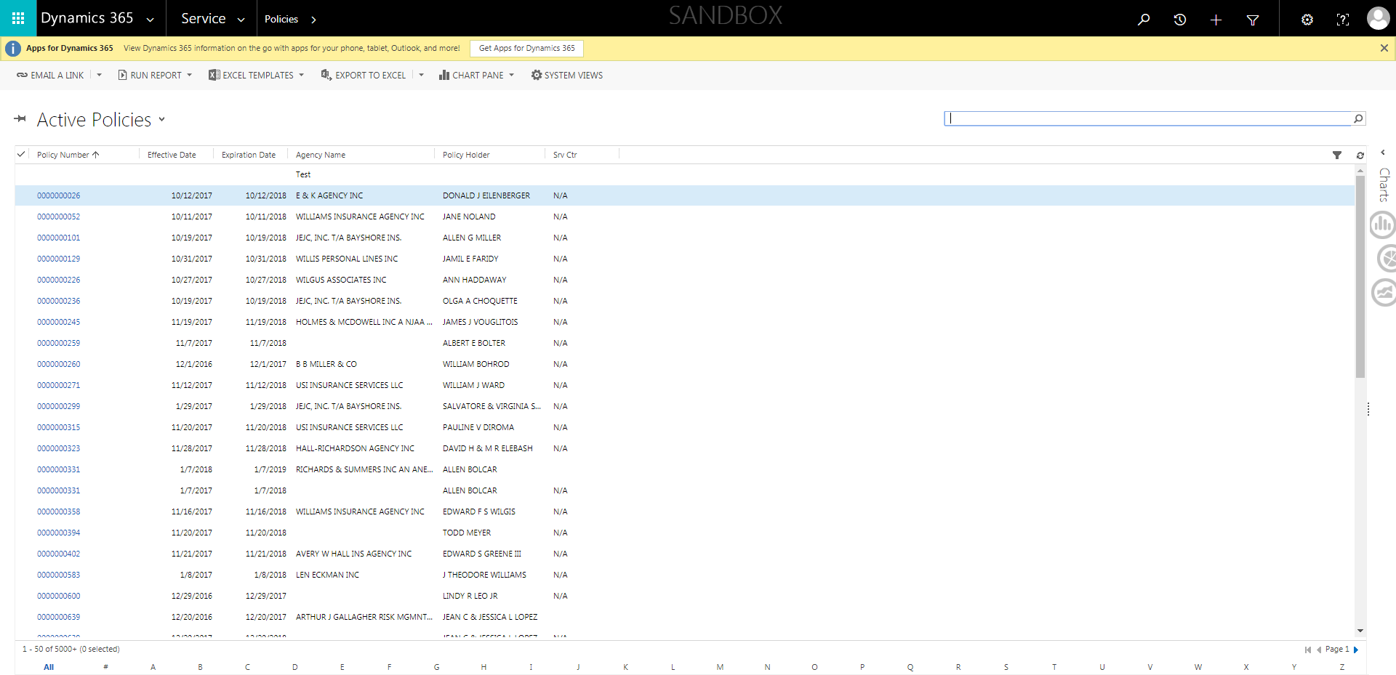

Policies_Verifying Agency Billed Policy_Instance43_29-May-2018_03-50-36_AM_MouseClickActiononStaleElement.png

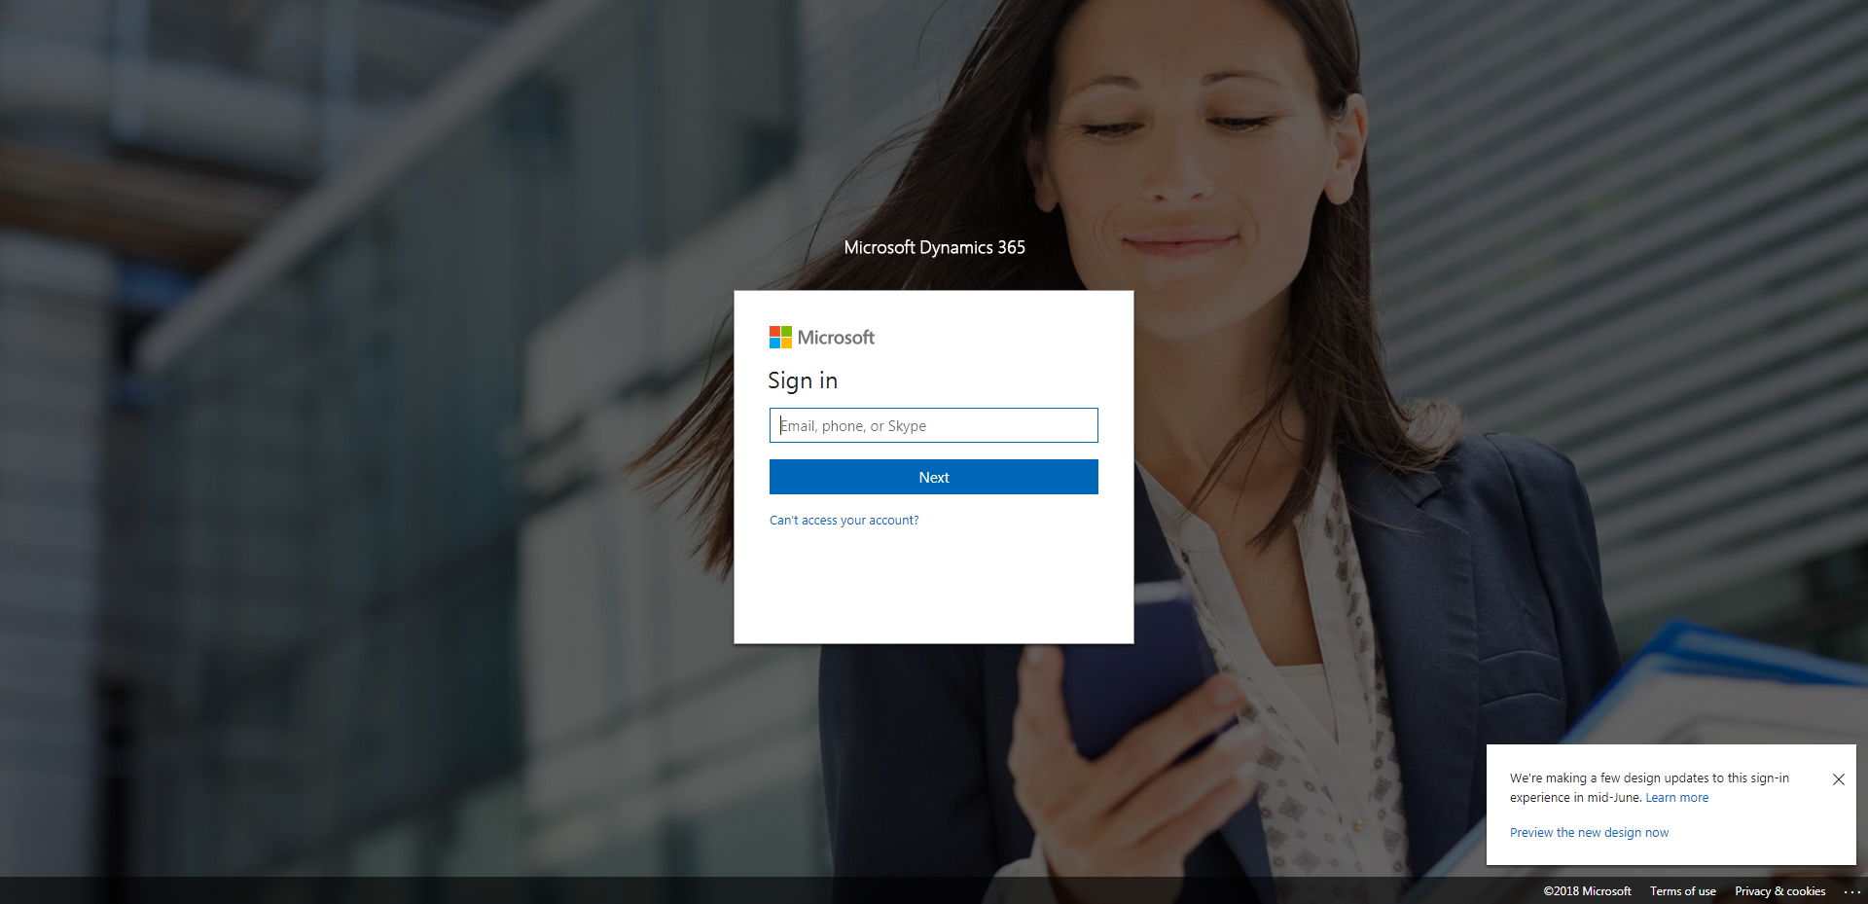

Policies_Verifying Agency Billed Policy_Instance43_29-May-2018_03-50-38_AM_EnterTextAction.png

